DIY Questions:

Samson is employed by a company as a Java Developer. For git operations,such as branch switching and branch creation in a repository, he requires assistance. To better understand git branching, Samson needs your help completing the following activities.

Tasks: 1.Create a working directory and initiate git into it

2.Create a newbranch in the local repository

3.Create a new branch as a Dev branch

4.Switch to the Dev branch

5.Create new files and commit files in the Dev branch

6.Checkout to the master branch

7.Merge the Dev branch to Master branch

Solutions:

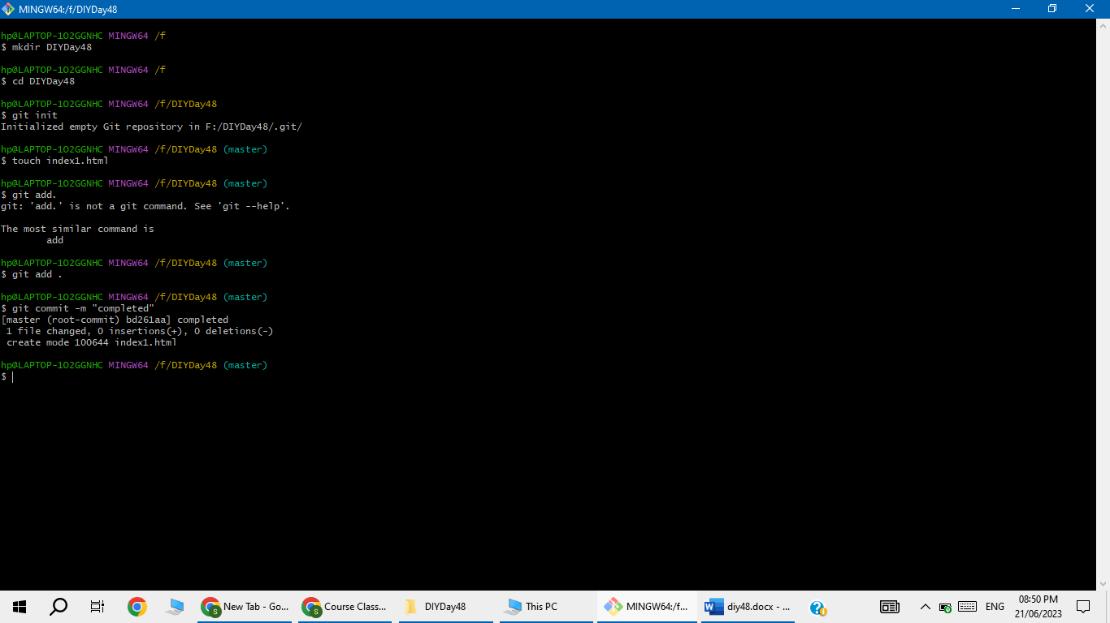

* Master branch doesn’t contain index2.html so for that we have to merge the master branch with Dev branch

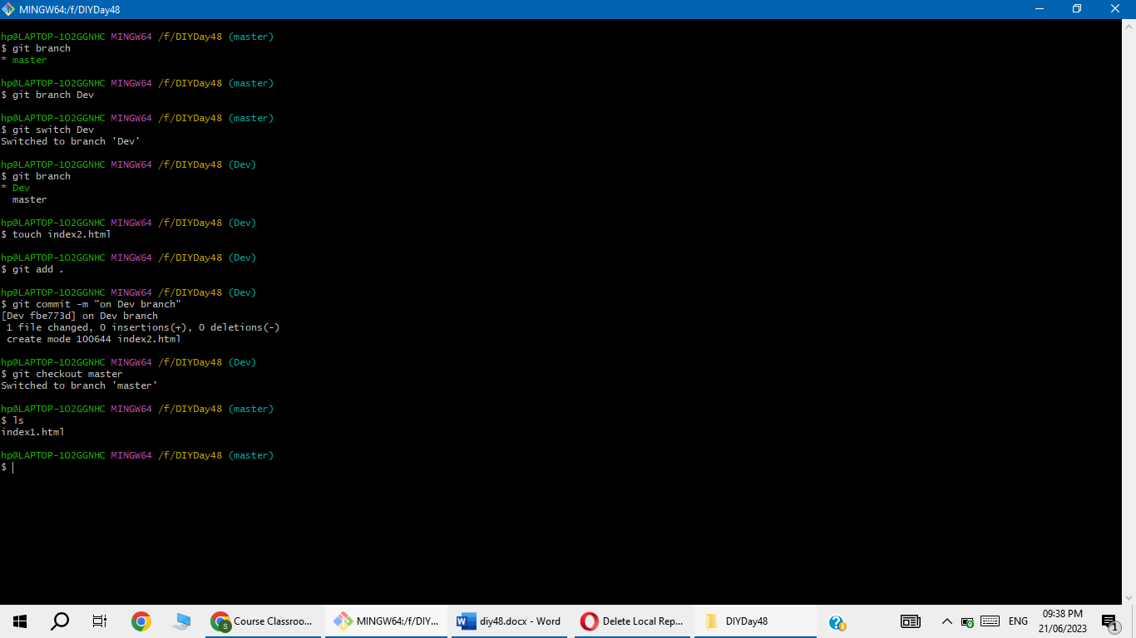

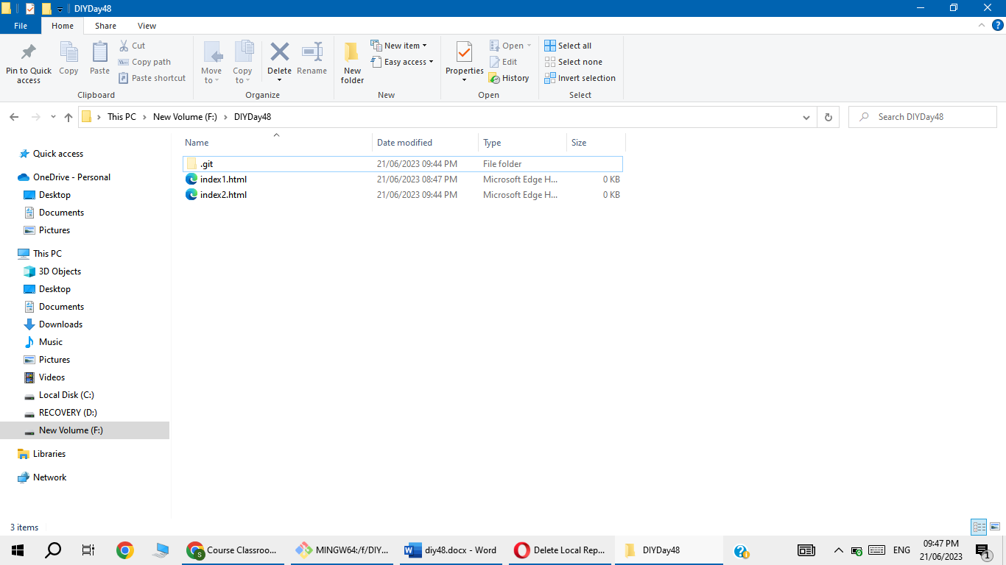

* To copy index2.html file form Dev branch to Master branch use Merge command

